**Leader Overview**

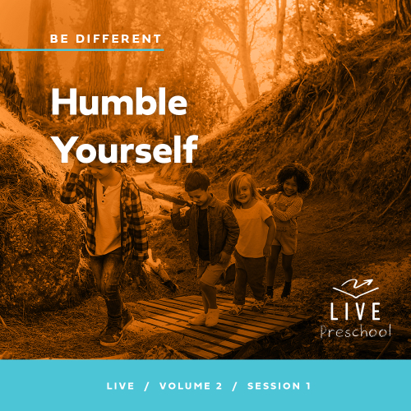

**Volume Overview**

**Be Different**

*Christians have long understood that we live and walk a fine line. We are to be in the world—all things to all people, as Paul put it—yet not of the world. God’s people have always been a chosen people, holy and set apart from the world’s ways. To pull it off, to be truly different, means we must each hold fast to the truth, speaking it when needed, all while humbling ourself and faithfully serving others.*

**Session Overview**

**Humble Yourself**

*In this* **Live** *session, preschoolers will discover that Jesus calls us to be different from the world by putting others first. When some party guests were trying to get the best seat, Jesus taught them which seat they should desire. Through that story, kids will explore how acting humbly and helping others feel important are powerful ways to show Jesus’ love to them.*

**Bible Lesson**

Party Guests Discover the Best Seat

[Luke 14:1](https://ref.ly/logosref/Bible.Lk14.1), [7–15](https://ref.ly/logosref/Bible.Lk14.7-15)

**Faith Fact**

I will put others first.

**Faith Verse**

[Romans 12:2](https://ref.ly/logosref/Bible.Ro12.2) (NLT)

Don’t copy the behavior and customs of this world, but let God transform you into a new person by changing the way you think.

**Preparing for the Session**

**Leader Preparation Time: 20–25 Minutes**

|  |
| --- |
| ***You Will Need***  ***Preservice Activities***  *• Chairs*  *• Sticker*  *• Small prize for winner*  *• Multicolored fish crackers or fruit snacks*  *• Toys*  ***Large Group***  *• Bible*  *• Worship songs (Song suggestions: “Boom” by GO Kids; “For All My Days” by Gateway Kids Lyric Video; “Jump” by River Valley GO Kids Music)*  *• For groups not using a phone or tablet only, add:*  *• Projector or TV*  *• Laptop*  *•* ***Faith Fact Sound*** *video (bell ringing)*  *•* ***Faith Fact Slide***  *•* ***Faith Verse Slide***  *•* ***Faith Verse Video***  *•* ***Bible Lesson Video A***  *•* ***Bible Lesson Video B***  ***Small Group***  *•* ***Small Group Activity Page****, one per kid*  *• Crayons or markers*  *• Floor safe tape (masking tape or painter’s tape)*  *• Tape measure*  *• Rubber floor spots or sheets of paper, ten per group*  *To access session content and videos from a computer, visit:* [***BibleEngagementProject.com/downloads***](https://bibleengagementproject.com/downloads) |
| ***Getting Ready***  ***Preservice Activities***  *• Set out toys and snacks.*  *• Arrange chairs in a circle.*  *• Place a sticker or special mark under one of the chairs.*  ***Large Group***  *• Download videos and slides if needed.*  *• Select worship song(s) and have them ready to play.*  ***Small Group***  *• Print copies of the* ***Small Group Activity Page****, one per kid.*  *• Place two tape lines about five feet apart to be the start and finish lines.*  *• Place smaller lines of tape, approximately one foot in length, throughout the area in a random pattern.*  ***First time leading* Live *for Preschool? Check out the*** [**Facilitator Guide**](https://0b769b0ed3569ef9d18b-f88d8272f61086866d50d048b43ef630.ssl.cf2.rackcdn.com/sites/biblengagementproject/Listen_Facilitator_Guide.pdf)**.** |

**Preservice Activities**

*See what’s needed at the beginning of the session.*

**Bible Story Warm-Up**

• *As kids arrive, have them choose a place to sit.*

How many of you go to school or daycare somewhere? *(Group response)* When you go there, do they make you stand up all day long? *(Group response)* I have a feeling that they ask you sit down sometimes just like I did when you came in.

What kinds of things can you sit on?

What are some silly things you can sit on?

Why did you pick the chair you’re sitting on now?

Wow! You had some really great answers. Today, when you picked your spot, one lucky person picked the prize chair. When I say, “Go,” I want you to stand up and look under your chair to see if you have something special under it. Ready? Go.

• *Give kids time to look under their seats.*

Great job! Because you picked the special seat, you get a prize! *(Give the prize.)* In the Bible, Jesus teaches us an important lesson about the seat we choose. Did you know Jesus says it’s important to pay attention to others when we pick a seat? *(Group response)* If the special seat would have had *(insert another kid’s name)* name on it, would *(prize winner’s name)* have sat there? No! Whose chair would it have been? *(Group response)*

That’s right! It would have been silly to sit in someone else’s chair and maybe a little selfish. Can you say that after me? Selfish. *(Group response)* That’s a funny sounding word that means we put ourself first. Sometimes when we choose to be in someone else’s spot, we’re being selfish. Jesus wants us to be humble, which means to put others first. I can’t wait to learn more about this together with you today.

**Snack**

**Multicolored Fish Crackers or Fruit Snacks**

We have a fun snack for you today. Before you eat it, you have a job to do.

• *Hand out snack.*

Before we start, I have a question for you. Does anyone have a favorite color? *(Group response)* Me too! On the count of three, I want you to tell me your favorite color. 1, 2, 3. *(Allow responses.)* Whoa! That’s a lot of great colors.

Before you eat your snack, I want to see who can sort their snack the fastest into groups by color. Don’t start until I say, “Go.” Ready? Go!

• *Allow kids about 30 seconds to sort their snacks into groups of colors.*

Great job sorting! My favorite color is *(say one of the snack colors)*. I want you to give me all of your snacks that are my favorite color. *(Pause for a moment while kids begin to respond or not.)*

Wait! Was it easy to share part of your snack with me? *(Allow responses.)* It’s not always easy to share or to let others go first, is it? *(Group response)* That’s what we’ll learn more about. I want you to go first and eat my favorite color of snack.

• *Let kids take turns naming colors of snacks and eating them.*

• *Continue through the colors until you have mentioned all the colors.*

That was fun! I’m glad I let you eat my favorite color snacks. Putting others first always makes me feel good. Today, we’ll find out why putting others first is so important to Jesus.

**Free Play**

*Any extra time can be spent playing with toys.*

**Transition**

*A few minutes before service begins have kids make their way to the large group area and sit in their designated areas.*

**Large Group**

**25 Minutes**

*See what’s needed at the beginning of the session.*

**Introduction**

Hi, kids! My name is _________. Now I want to hear all of your names. On the count of three, shout out your name. *(Lift hand and count with fingers)* 1, 2, 3! *(Group response)* Wow! I’m so glad you’re here today! We’ll have so much fun learning from God’s Word together. *(Hold up the Bible.)* If you’re excited to be here, raise your hand! *(Group response)*

Today, we’ll find out about Jesus going to a dinner. Have you ever gone to someone’s house to eat a meal? *(Group response)* In our Bible story, people were at a meal, and they all wanted the very best seat at the table.

**Faith Fact**

Jesus taught the people at that dinner and all of us a really important lesson about putting other people first. That’s why our Faith Fact is **I will put others first.**

• *Show the* ***Faith Fact Slide.***

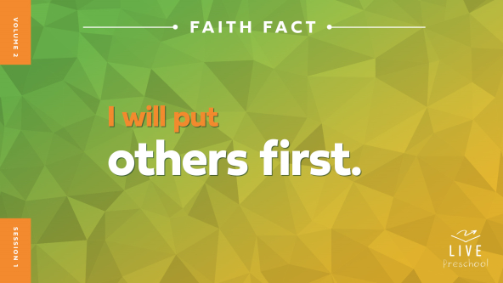

Let’s say our Faith Fact together. When we say the word *first*, hold up a number one with your finger. *(Demonstrate holding up pointer finger.)* **I will put others first.** Great job! Let’s say it again. **I will put others first.** Now, I want you to respond with the Faith Fact to what I say. I want to put others first. How about you? **I will put others first.**

**Bible Time**

One of the most important things we do together is learn from God and His Word, the Bible. We have special friends to help us do that. Let’s see what Lizzy and Grandpa are doing.

• *Play* ***Bible Lesson Video A.***

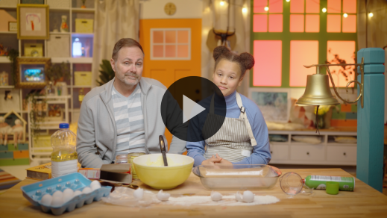

I’m glad Grandpa gave us a little time to think. Let’s worship Jesus now. Then, I’ll ask you what you think will happen next in our Bible story.

**Worship**

One way we show Jesus how much we love Him is through praise and worship. We get to tell Jesus that we know He is good and strong. We get to think about how much Jesus loves us, and we get to show Jesus how much we love Him.

**Praise**

Who knows that Jesus loves you? Give yourself a big hug. *(Group response)*

Are you glad Jesus teaches us to put others first? Give me two thumbs up. *(Group response)*

Who wants to thank Jesus? Wave your hands up high. *(Group response)*

**Sing**

Let’s use our voices in singing to worship Jesus. He deserves all our praise.

• *Lead the kids in singing one or two songs. See song suggestions at the beginning of the session.*

**Prayer**

Jesus heard all our voices singing together. The Bible tells us that our worship sounds sweet to Him. Now, let’s talk to Jesus in prayer. He is with us and loves it when we talk to Him. Let’s pray.

|  |
| --- |
| *Dear Jesus, thank You for walking on the earth as a person so that You could show us how You want us to live. You are so good to us. You love us and want good things for us. We praise You, Jesus. Amen.* |

**Bible Time cont’d**

• *Start* ***Bible Lesson Video B*** *and pause on the image of the two choices.*

I think Grandpa and Lizzy will be back soon. Let’s think about the answer to what happens next in our Bible story. Should we put on our thinking caps? *(Demonstrate.)* What do you think happened? Did Jesus tell them to try to be first and get the best seat? *(Point to the “#1 foam finger” graphic.)* Or did He say to stop and put others first? *(Point to the “stop sign” graphic.)*

If you think Jesus said we should all try to be first, hold up one pointer finger. If you think Jesus said to put others first, bend over in a little bow like you’re being polite. Ready? Choose your answer.

• *Pause while kids respond.*

Let’s find out if you’re right! Let’s check back in with Lizzy and Grandpa.

• *Play* ***Bible Lesson Video B.***

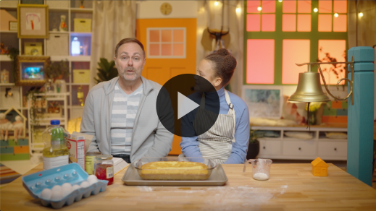

**Response Time**

*Play a worship song quietly.*

Now, we’ll respond to what we’ve learned today. Let’s bow our heads to show Jesus He’s the most important person in our life. We want to say yes to showing His love to others. Let’s ask Him to help us put others first.

• *Have the kids repeat phrases of the prayer after you.*

|  |
| --- |
| *Dear Jesus, I want to show Your love to my friends and family. You know it can be hard to put others first, but You will always help me when I need it. Please show me how I can put others first. Help me to do that at home and with my friends. Amen.* |

**Faith Verse**

God loves it when we learn Bible verses. Our Faith Verse tells us not to copy the world. People who don’t love Jesus would say that we should only care about ourself, but God can change the way we think and live. He can help us care about others. Let’s say our new Faith Verse and do the actions together.

[Romans 12:2](https://ref.ly/logosref/Bible.Ro12.2) (NLT)

Don’t copy the behavior and customs of this world, but let God transform you into a new person by changing the way you think.

• *Show the* ***Faith Verse Video****.*

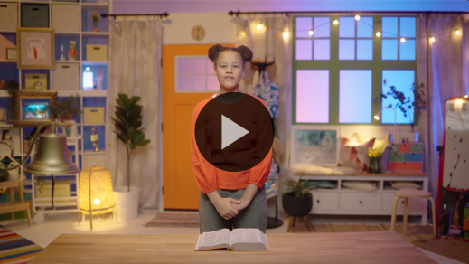

**Romans** *(hands at waist, spread apart, palms up and out)*

**12:** *(hands together like a clap)*

**2** *(hands opened to “book”)*

**Don’t copy** *(make* X *with forearms)*

**the behavior and customs of this world,** *(cross arms across chest and frown)*

**but let God transform you** *(point to sky and smile)*

**into a new person** *(spin around)*

**by changing the way you think.** *(put hands on head like a helmet)*

**Closing**

I’ve loved learning more about Jesus with you today! Did you enjoy worshipping God by singing and praying together? *(Group response)* We also discovered a great Faith Verse from the Bible about letting God change the way we think. I know I will be asking God how I can put others first and show them His love. Will you do that this week? *(Group response)*

• *Play the* ***Faith Fact Sound*** *video (bell ringing).*

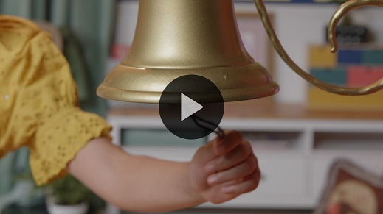

That sound means we get to say our Faith Fact one more time: **I will put others first**.

• *Show the* ***Faith Fact Slide.***



Let’s shout the word *others* extra loud when we say it. Ready? **I will put others first**. Let’s shout out the whole Faith Fact one more time. **I will put others first.**

**Dismissal to Small Groups**

Great job, everyone! Now, we get to go to our small groups with our wonderful leaders and friends. Let’s have some more fun together!

• *Dismiss the kids by groups.*

|  |
| --- |
| ***Leader Tip:*** *This can be done by assigning color teams or by age groups. Note that some young preschoolers may not know their age. Using a colored sticker, jersey, or wristband will help separate the kids and help identify their small groups.* |

**Small Group**

**25 Minutes**

*See supplies and prep instructions at beginning of session or in each activity below.*

|  |
| --- |
| ***Leader Tip:*** *Small groups can alternate to each circle, or all groups can do each activity at the same time. If you choose to alternate, you will need at least one leader per circle.* |

**Circle 1**

**Group Connection**

**Copy, Copy, No**

|  |
| --- |
| *No prep needed for this activity.* |

If you’ve had fun so far today, I want you to turn around three times when I say, “Go.” Ready? Go! *(Group response)* Whoa, you must have had a ton of fun! I have some good news for you. The fun is not over. In fact, we have a super fun game to play right now. Let’s sit in a circle.

• *Have the kids sit in circle.*

I want to see how good you are at copying sounds. First, I need you to listen to these instructions. If you’re ready to listen, place your hands in your lap. *(Group response)* I’ll start the game by making a sound or doing an action. Then, I’ll tell you how to respond. For example, I might bark like a dog *(demonstrate)*. Then, if I say, “Copy,” you’ll copy me and make a dog sound. If I say, “No,” then you won’t say anything. Let’s try it.

• *Make a dog sound and say, “Copy.”*

• *Make a different sound or do a simple action (e.g., laugh or clap hands) and say, “No.”*

Amazing! Friends, you caught on so quickly! If you’re ready to play, raise your hands and wave them in the air! *(Group response)* Let’s play.

• *Repeat activity for as long as time allows. Use the pattern copy, copy, no, so younger kids can catch on the changing of responses.*

Wow, all this copying or not reminds me of what our Faith Verse teaches! Our Faith Verse teaches us that we should not copy the things the world does. That means we shouldn’t do the bad things that people who don’t follow Jesus do. Instead, we should copy Jesus and let Him change the way we think and live. In fact, I think now is a good time to practice our Faith Verse together.

[Romans 12:2](https://ref.ly/logosref/Bible.Ro12.2) (NLT)

Don’t copy the behavior and customs of this world, but let God transform you into a new person by changing the way you think.

• *Review the Faith Verse using the Faith Verse actions.*

**Romans** *(hands at waist, spread apart, palms up and out)*

**12:** *(hands together like a clap)*

**2** *(hands opened to “book”)*

**Don’t copy** *(make* X *with forearms)*

**the behavior and customs of this world,** *(fold arms across chest and frown)*

**but let God transform you** *(point to sky and smile)*

**into a new person** *(spin around)*

**by changing the way you think.** *(put hands on head like a helmet)*

That was amazing! I love how hard everyone is working to learn this Faith Verse.

**Circle 2**

**Activity Page Time**

**Best Seat Match Up**

|  |
| --- |
| ***You Will Need***  *•* ***Small Group Activity Page****, one per kid*  *• Crayons or markers*  ***Getting Ready***  *• Print copies of the* ***Small Group Activity Page****, one per kid.* |

Today, we’re learning that we should put others first. That’s what our Faith Fact says. Say it with me. **I will put others first.** *(Group response)* That’s great! In today’s Bible story, Jesus gave some pretty amazing advice when people were trying to find the best seat at a dinner.

• *Hand out the* ***Small Group Activity Page*** *and crayons or markers.*

On your page there are four different seats. Point at the one you would like to sit in. *(Group response)* Some of those seats might be pretty awesome like the throne. It’s so big and fancy. That might be fun to sit in, but that special seat is best for someone else. Let’s see if you can figure out who it is. Point to the one who should sit on the throne. *(Group response)* It’s the seat for the king. Draw a line from the king to the throne.

• *Help kids draw the line if needed.*

Do you think you can figure out which seats everyone else should sit on? *(Group response)* Go ahead and draw lines to match up everyone with the right seat.

• *Be ready to help kids as needed.*

• *During the activity, interrupt and practice the Faith Fact:* ***I will put others first.***

• *Play the* ***Faith Fact Sound*** *video. Review the Faith Fact even if you can’t play the sound.*



Amazing! You all did such a good job of matching the seats. I know everyone is so happy that you put them in their best seats!

**Circle 3**

**Feet-to-Floor Game Time**

**You Go, I Go Relay**

|  |
| --- |
| ***You Will Need***  *• Floor safe tape (masking tape or painter’s tape)*  *• Rubber floor spots or sheets of paper, ten per group*  ***Getting Ready***  *• Place two tape lines about ten feet apart between the start and finish lines.* |

Jesus taught us that when we choose to put others first, it makes God happy. There might be times when it’s hard to put others first. You might want the best thing for yourself, like being the leader all the time. But if we’re always pushing other people out of the way, we won’t be first the way Jesus wants us to be. Instead, if we put others first, we can lead by loving our friends like Jesus does.

If you’re ready to play a fun game to practice putting others first, say, “Oh, yeah!” *(Group response)* Today’s game will require partners. What does our Faith Fact say? **I will put others first.** That’s right! So the partners will play by letting each other go first. On the way over to the other side of the stepping spots, one person will go first. Then on the way back, the other person gets to go first.

There’s one thing you have to watch out for. If anyone misses the spots and touches the floor, their turn will be over and two more kids will get to go across on the spots. Let’s see if we can get everyone safely to the other side and back. Who wants to try first? *(Group response)*

• *Allow the kids to choose a partner and make it across and back.*

• *If kids miss the spots, have them go to the end of the line and try again.*

Wow! You did a really good job of putting others first. What was the hardest part of that game? *(Allow responses.)* What was your favorite part of that game? *(Allow responses.)* I loved getting to cheer you on as you put others first!

**Circle 4**

**Hands-On Learning**

**Follow the Leader**

|  |
| --- |
| *No prep needed for this activity.* |

Who can tell me our Faith Fact? *(Allow responses.)* That’s right! Let’s all say it. **I will put others first.** Now, we’ll play a game called Follow the Leader. Have any of you ever played that game before? *(Group response)* If you have never played it, here is what we’ll do.

One person is chosen as the leader. The leader will give the rest of the group directions and try to make up fun things for everyone to do. It could be skipping, turning in circles, walking crooked, some fun action. Then, our leader will do what Jesus taught people to do in our Bible story and let someone else to go. That person will lead the group in one action and then choose someone else to go next.

• *Allow the leader to tell the group what to do and choose who will lead the next action.*

Good job leading our group and doing what our Faith Fact says: **I will put others first**.

• *Keeping playing until you run out of time.*

You did a great job of putting others first and choosing others to lead the game.

**Dismissal**

• *Play the* ***Faith Fact Sound*** *video (bell ringing).*



• *Show the* ***Faith Fact Slide.***



Wow, friends, our time is almost over! I’ve had so much fun learning about God’s Word with you today. Before we go, can we all say our Faith Fact together one more time? *(Group response)* Let’s all reach up high and grab our *(say in big booming voice while reaching high)* big, tall voices. **I will put others first.** See you next time! I can’t wait to learn with you again then.

• *Send home the* ***Small Group Activity Page*** *with each kid.*

• *Remind parents that there are* ***Family Devotions*** *available on the app to do with their kid.*

• *Tell everyone the date and time for the next session.*